**Water Management system**

**Complied by: RASHID ABDULRAHMAN**

**Report No: RA-001**

**Table of contents**

1.1 Simulation 2

2 Simulation/Testing 3

2.2 Prototype Circuit Drawing 7

## Simulation

A simulation is a model that imitates the operation of a proposed system. An intelligent software such as proteus simulator can be used to build a visual sample that appears or feel close to the real model, by adding/connecting components and restrictions that makeup a proposed system can represent a desired model.

### Simulation Model

Below is a proposed water management system model that was created using proteus 8.2 to mimic the behaviour of the water management system. A system below consists of 2 Ultrasonic sensors, 1 LCD 16x2 screen, 4 resistors which shall be used to mimic the distance range between sensors and water using Arduino Uno. Arduino program REF[7] shall be created on Arduino IDE and inserted into proteus software to observe the behaviour of the system

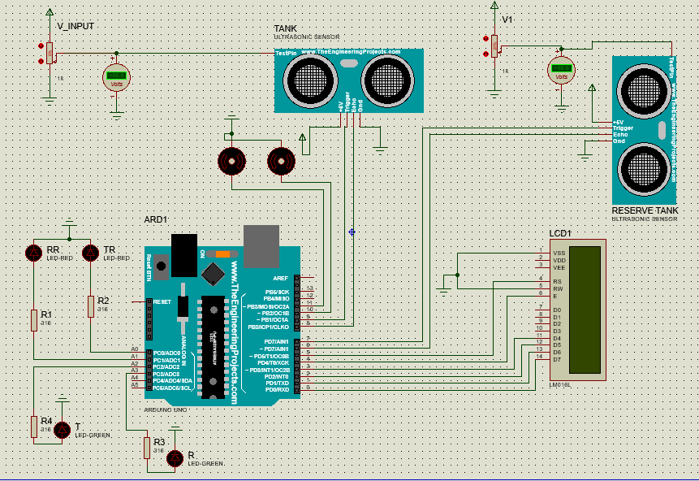

Figure 7

# Simulation/Testing

Testing is a vital stage in the project development not only for proving the design and highlighting potential problems early in the development cycle. Excellent communication channels between design and production are essential to successfully manufacture and address any issues that arise during production, in order to meet any requirements. The first few tests were carried out using proteus simulation program to check the function of the Arduino code and how every component behaves.

### Simulation 1

The first was carried out on proteus simulator to simulate the function of the lcd display and to check if the circuit future circuit will work with this configuration, this was done by connecting Arduino Uno to 16x2 LCD library and push on a hello world program that was created on Arduino IDE

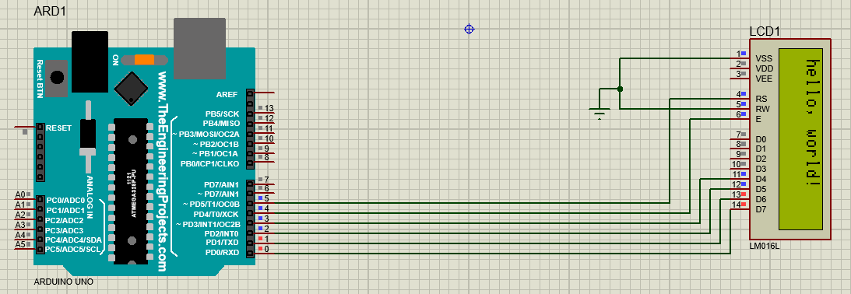

Figure 12

Figure 12 above shows a successful simulation of Arduino and LCD display. Through this configuration, it was noted that this configuration can be used to display future functions.

### Simulation 2

The second test was carried out was carried to check the function of HC-SR04 ultrasonic sensor, this was done by connecting the sensor to the Arduino circuit shown in figure……at this point the first part of the program that is going to be used in the water management system was created, to display the distance (on the LCD) that has been detected on the sensor and also to show water level using selected syntax.

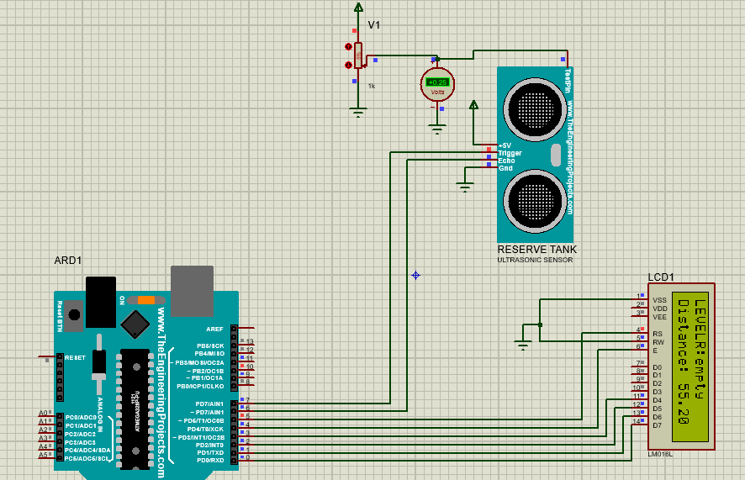

Figure 13

Figure 13 shows a successful simulation. During a simulation, a distance below 50cm was chosen to represent a tank and anything above 10 cm was chosen to represent a full tank and As shown on the display a distance of 55cm represented an empty tank(LEVELR:empty)

### Simulation 3

The third test was conducted by adding a first motor to the circuit and observe its state according to the written Arduino program. According to the program the motor turns on when the water reaches below average level

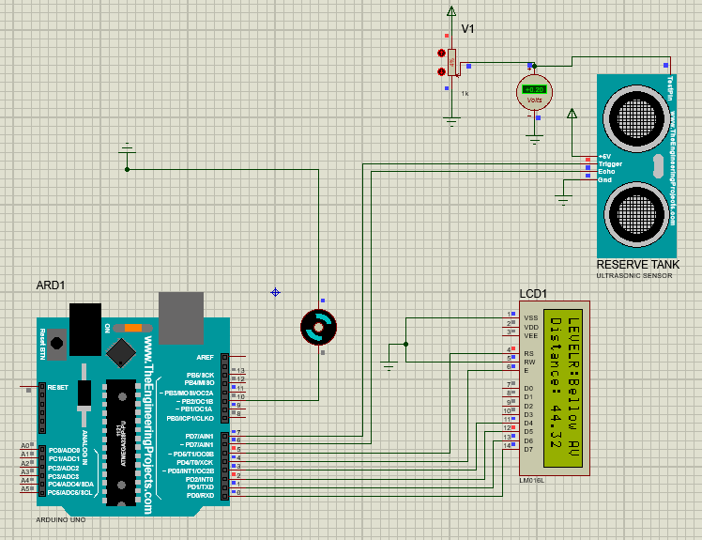

Figure 14

Figure 14 above shows a succefull simulation of DC motor .this was carried out by uploading an Arduino program that activate (turn on) the motor when the water level show as LEVEL reaches below Av and deactivate (turn off) th motor when water level reaches full.

### Simulation 4

After a useful test (as shown on figure 14) it was time to add an extra Motor and HC-SR04 motor to the simulation circuit. This test was simple as there were no major changes to the Arduino program because both motors and sensors operate using the same algorithm.

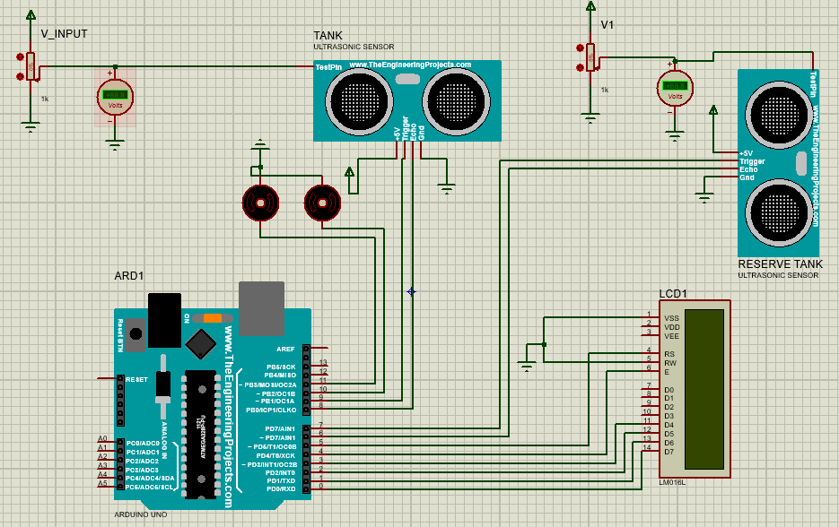

Figure 15

### Simulation 5

Figure 16 below shows the final simulation circuit that will be used to produce a prototype of water management system. The final figure consists of 2 set of LEDs (2 red and 2 green) for each motor. LEDs shall be used to show a motor state where a green LED will turn on when a motor is high (on) while red LEDs will state Low (off) motor state.

## Prototype Circuit Drawing

Prototyping is generally used to inspect for aspect such as design flaws, ease of use or anything critical that will determine the success of the product.

Below is a conceptual Fritzing drawing of the prototype circuit design of the water management system. The drawing shows a first stage of porotype design where all the components are connect into a breadboard and are connected to Arduino Uno using strip wires.

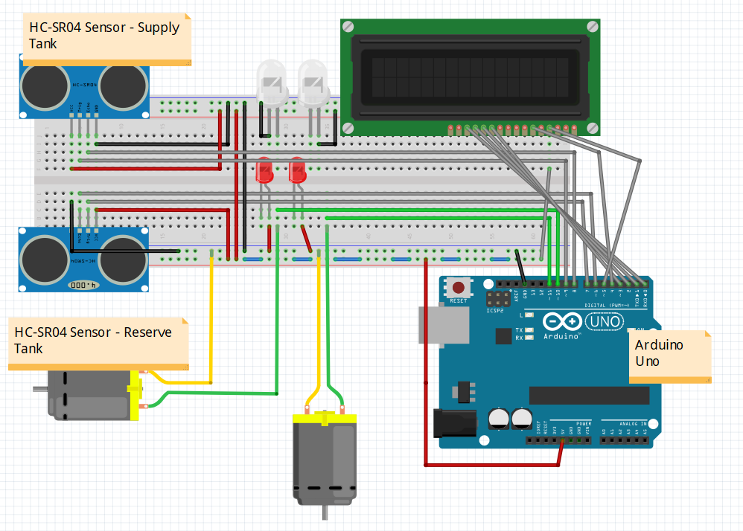

Figure 9

Above figure shows a prototype circuit design that was created using fritzing. This circuit shall be used to produce the first prototype design.

### Prototype 1

Below on figure 10 shows a first prototype design that was carried out after a successful simulation REF [6].this prototype design was based on a fritzing design REF [9.1]. This stage has been carried out to test the characteristics of the circuit in the real world scenario.

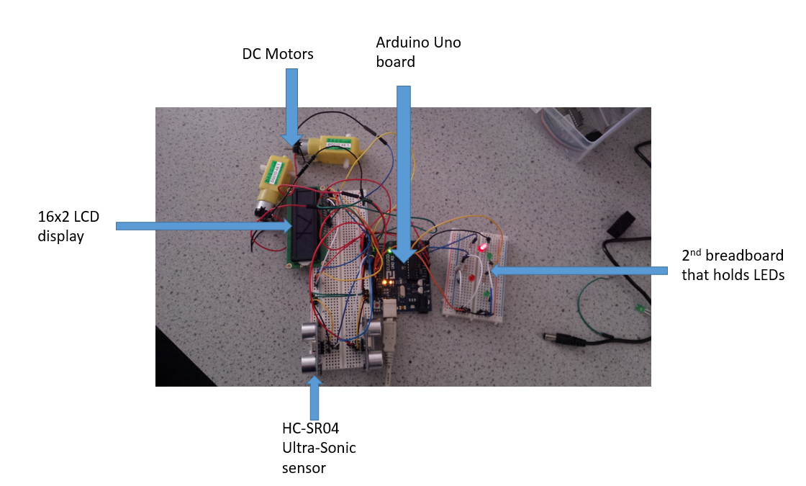

Figure 9

As shown on the picture above in figure 10 the prototype design did not go as planned as there were no enough space on the breadboard for LEDs therefore a second breadboard had to be used to complete the circuit.

### Prototype 2

After redesigning the circuit and making sure all components are connected to the circuit, it was time to upload the code to the Arduino. This was accomplished using a USB port and Arduino IDE. The second prototype didn’t go as planned as the 2 motors did not turn on and one set of LED was not functioning. After few inspection it was calculated that the Arduino program worked fine and program issue was ruled out, the only 2 possible issues that might have caused the problems were the connection to those components were loose or broken and the biggest and possible issue was probably that there was no enough current supplied to all the components and therefore another power supply is needed.

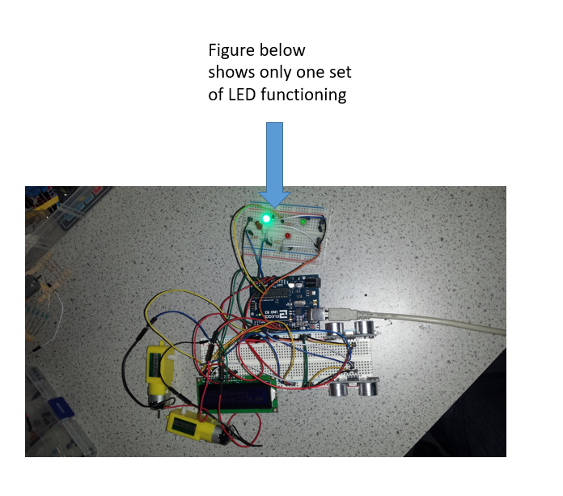

Figure 11

### Prototype 3

Another issue that was noted on this testing was that the LCD was not powered on at its maximum brightness and the only issue that might have caused that was lack of current in the circuit because everything was connected to 5volts supply that was supplied using Arduino Uno 5volts supply.

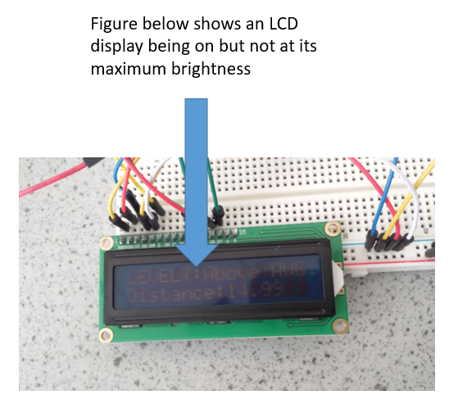

Figure 12